Material and Texture Animation With NifSkope:
Part 1: An Introduction
A tutorial from Pixelhate. 2014.
Contact Information: Pm Pixelhate at http://forums.nexusmods.com/index.php?showuser=1205226
This guide is the result of compiling information on the use of NifSkope by reading tutorials (some quite outdated) and Wikis, tracking help posts on forums or by trying to figure things out by myself.
This work was possible thanks to too many people to name them all. Some of their words where just copy/pasted here, as things where explained better than I will ever be able to do.
I am forever grateful for their generous act of sharing knowledge.
So, if this guide is ever useful to you, it is thanks to them.
Please, see credits and links at the end of this document.
This part comes from a package with 4 parts in Pdf or Doc format and with a series of meshes and textures, referenced in the following pages. A series of flow charts images summarize the steps for each animation type.
If you received this tutorial without these resources, please visit http://www.nexusmods.com/fallout3/ and download the full package.
Tutorial is in four parts:
Part 1 this Introduction.
Part 2 about Material Animations.
Part 3 covering Textures Animations.
Part 4 will deal with Controller Managers, Sequences and Scripts.
Table of Content
- Introduction
- Pre-requisite
- Material and Method
- Generalities
- Duplicating, Copying, Inserting and Removing
- Geck Preview
- NifSkope Preview
- Animations Type
- UV Maps
- Structures
- Shaders
- Credits
This tutorial is focused on Static or Havoked object. No skins, armors or weapons have been tested.
All information shared here is meant for Fallout 3, but most probably will work for FNV as well.
Introduction
Material properties affect the general nature of how the material of an object is rendered in game; it can glow or reveal transparency. These conditions can be changing in a certain time frame. That is what Material animation covers.
The effects can be Alpha (transparency) and Emissive (glow).
A lot of textures are animated in game (FX, fire and explosion, screens, etc.).
Look at the mesh as a screen, with the texture projected onto it and use dynamic effects such as panning or zooming. That is what Texture animation is about.
The effects can be Rotation, Scaling and Translation.
All the animations can be combined.
Pre-requisite
The latest version of NifSkope.
The Geck + patch 1.5 or the Geck Powered Up
Fallout 3
It is assumed that the reader has a good basic understanding of the structure of a Nif and the procedures for basic NifSkope operations such as adding, copying, inserting and removing nodes.
It is also assumed that the reader has a basic understanding of what an UV Map is and does, and how to view and transform it in NifSkope.
See some refresher in Generalities section and useful links in credits section.
Material and Method
After some theoretical elements, detailed step by step instructions are given for each operation, with pictures. Exercises are proposed with some increasing complexity.
Nifs referenced in the following pages are provided. They contain two planes aside, one with the demonstrated animation set, the other blank, for you to (re)build the animation.
Two meshes of a camera monitor come with the last part of the tutorial.
The textures are custom, 512x512 and designed to help understanding the effect showed.
Place the meshes and textures in the appropriate folder (……\data) to view and test them in game.
Keep a back up of the original files.
There are a lot of settings and it’s easy to get lost.
Explanations are given according to the workflow I’ve developed.
While it isn’t mandatory, try to follow it and stick to it.
Once you understand the mechanics, it’s up to you to develop your own workflow.
You will be asked to save regularly. I do it by incrementing (MyFile01.nif, MyFile02.nif, etc.) and keep all the progress until I have achieved a final version. That way, I can always revert back to an earlier version in case of mistakes. Alternatively, I can try another approach at a certain point.

On a side effect, it will reorganize the blocks hierarchy and numbering. So be careful at which point you save your work.

Generalities
Copying, Duplicating, Inserting and Removing
You’ll use Insert to bring new data in a mesh.
You’ll use Copy/Copy Branch and Paste/Paste Branch functions for transferring data from one mesh to another (with several instances of NifSkope open).
You might need to (re)name array and properties to allow Copy/Paste.
You’ll use Duplicate/ Duplicate Branch function to multiply data inside one nif.
You’ll use Remove Branch to delete a block with sub-array.
As far as Texture Animation is concerned, I prefer to Insert new blocks instead of Paste/Copying blocks from other nifs, to avoid strange self branch renaming problems.
The Duplicate function inside a nif is a time saver, though.
Geck Preview
There’s a quick way to check your results using “the Mini Geck”.
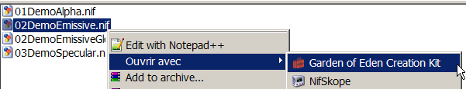
- A. Right click on a chosen nif and open it with Garden of Eden Creation Kit.
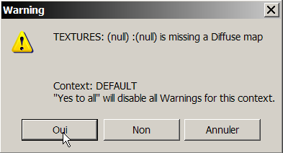
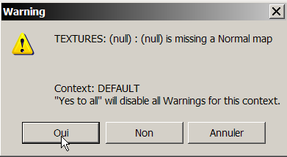
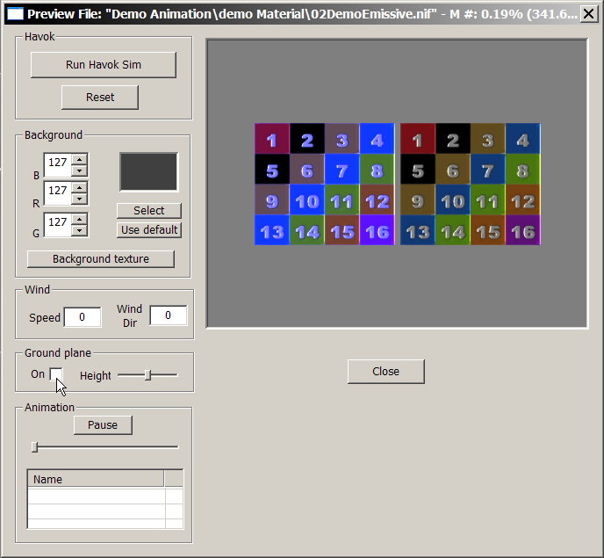
- B. Yes to both error messages.
If it’s crashing in Geck preview
then it won’t work in game…

- C. Uncheck Ground Plane On.
Preview your nif and play your animation, if any.

NifSkope Preview
NifSkope is a general purpose tool for editing nifs, with generalized rendering capabilities. NIfSkope’s renderings are best effort and do not specifically reflect how an object will be represented in any specific game.
You can’t really rely on NifSkope preview, especially with Animation Texture. Still, you can get a basic idea, most of the time. And it’s an amazing tool!
Start animation
Play looped
Select sequence
Animations type
There are 2 types of Material animations:
- Alpha
- Emissive

There are 3 types of texture animations which can be performed with 5 Operations:
- Rotation
- Scaling along U axis
- Scaling along V axis
- Translation along U axis (left/right)
- Translation along V axis (up/down)
Each Operation is managed by Interpolation keys.
Interpolation is the process of filling in the unknown data between two known values.
If you give 2 different values, the computer will calculate (interpolate) and render the frames between the given values.
The 5 different types of keys relate to the different ways of interpolate:
- LINEAR_KEY
- QUADRATIC_KEY
- TBC_KEY
- XYZ_ROTATION_KEY
- CONST_KEY
In my understanding:
LINEAR_KEY interpolation creates a uniform rate of change between key frames. The change between two given values will be constant.
QUADRATIC_KEY (or Quaternion Rotation Key) interpolation creates a triangular rate of change between key frames. Forward and Backward values are available. Change will be speeding up then speeding down between two given values. The speed factor is tweaked with Forward and Backward values.
TBC_KEY interpolation (Tension Bias Continuity) allows customizing the curved rate of change between key frames with three values added: X = Tension, Y = Bias, Z = Continuity. This allows to fine-tuning the changes between two given values.
XYZ_ROTATION_KEY interpolation (Seems to be dedicated to Objects animation, first tries with Texture Animation have lead to crash).
CONST_KEY interpolation will display the texture at the set key frames without transition. This allows frame by frame animation.
Interpolation can be seen as wave forms:
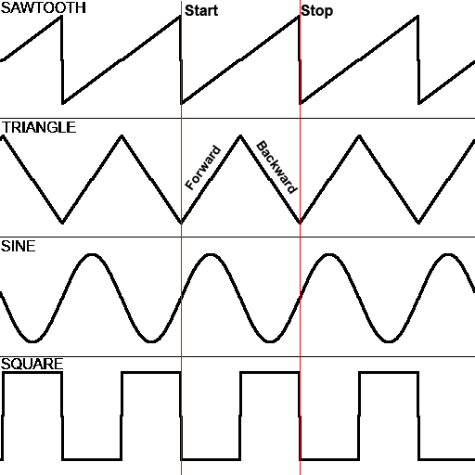
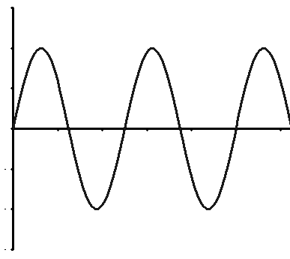
Where the additional TBC parameters are:
Tension
Bias
Continuity
LINEAR
QUADRATIC
TBC
CONST
To fully use the potential of the TBC settings, a high mathematic degree is required.
But experimenting can be fun and can lead to surprising and interesting results!
UV Coordinates (or UV map)
UV Coordinates are 2D Coordinates mapped onto a 3D model.
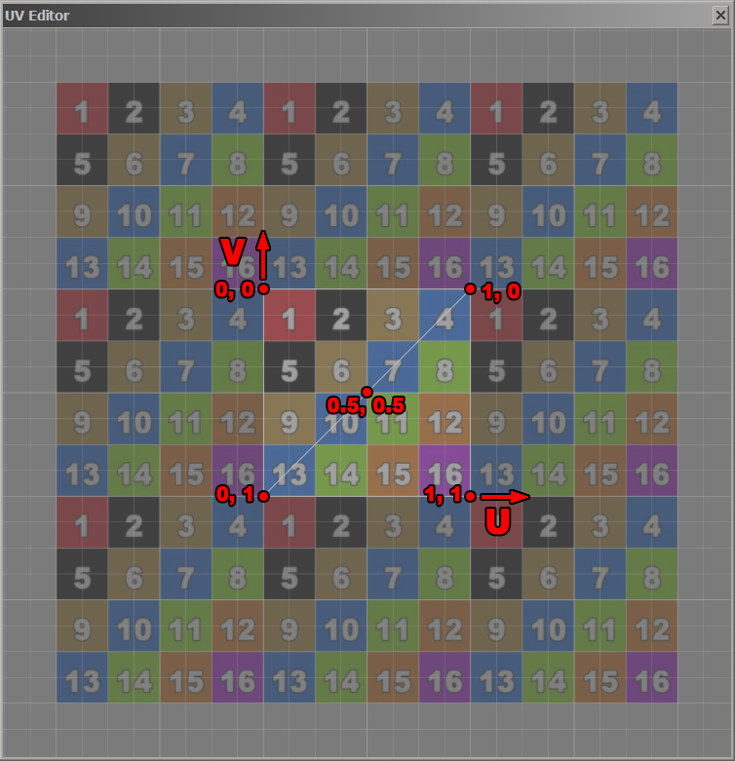
They are independent of the size of the texture map. The UV Coordinates may cover an entire texture or just a part of it. In NifSkope UV Editor, the texture is repeated all around itself and the UV Coordinates will determine which part is visible on the mesh.
Our UV Map covers the exact size of the texture and is centered to it.

You can perform several operations on the UV coordinates inside NifSkope: Selecting in different ways, Scaling, Translating, and Rotating. Undo/Redo is available.
For example: Scaling.
- On NiTriStrips right click  Texture  Edit UV
- In The UV Editor right click  Select all (UV Map should turn yellow)
- right click again  Scale and Translate Selected
- Enter Scaling Factor  OK

Although sometimes very useful made this way, these operations can also be performed in a “non destructive way” in NiTexturingProperty’s setting.

We’ll see more about this in part 3.
Structures
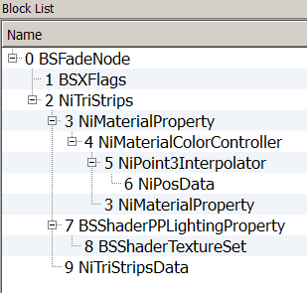
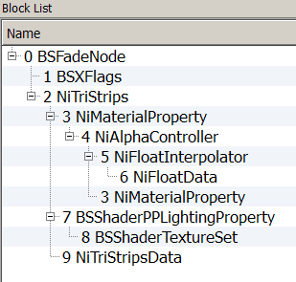
Material Animation
Basic structure for Material Animation.
Alpha.
The block controlling the animation is attached to the NiMaterialProperty.

Basic structure for Material Animation.
Emissive.
The block controlling the animation is attached to the NiMaterialProperty.

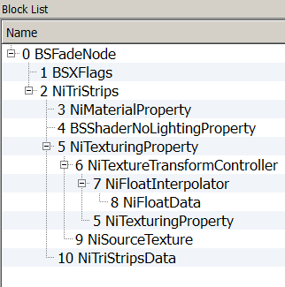
Texture Animation
Basic structure for texture Animation.
Rotate, Scale or Translate.
The block controlling the animation is attached to the NiTexturingProperty.

Shaders
Among the different shader type available, the two most commonly used with Static or Havoked objects are:

BSShaderPPLightingProprety (+ TextureSet = Diffuse, Normal, Glow, Environment Map, etc.)
BSShaderNoLightingProperty (+ NiTexturingProperty and NiSourceTexture = only Diffuse.)

Material Animation will work with both Shaders.

Texture Animation will work only with BSShaderNoLightingProperty.
Normal Maps aren’t supported with Texture Animation.
BSShaderNoLightingProperty will give an emissive/glowing effect to the texture, making it brighter under light and visible in the dark.

Time Vs. Frame

The Key Data Timing can be very precise and allow, theoretically up to 1000 events per seconds, however, the game can’t run that number of Frame per Second (FPS).
Asking the game to render more fames than possible by rendering may result in lag, freeze or crash.
Ten to twelve events per second is on the safe side and will trick the eye most of the time.
For reference cinema is 24 images/s and video 25 images/s.

Credits (Alphabetic)
I would like to thank deeply and sincerely.
- Anoxeron for his dedication, enthusiasm and benevolence. Thank you for testing each exercise, each step without respite and for giving me countless opportunities to improve this tutorial. Thank you for proof reading and corrections.
http://www.nexusmods.com/fallout3/users/3694499/?
- BrettM for his tutorial about Textures Animations for Skyrim, despite a big difference in the engine, his tutorial was an inspiration for layout and presentation.
http://www.nexusmods.com/skyrim/mods/47104/?
- Ghogiel for his guide about NiMaterialControlers, his resources and mods which are real learning material and for his kind private answers about Specularity.
http://wiki.tesnexus.com/index.php/Adding_material_controllers_to_objects_in_Nifskope
http://www.nexusmods.com/fallout3/users/209926/?tb=mods&pUp=1
- Nexus for hosting this.
http://www.nexusmods.com/fallout3/
- Prensa for her kindness, constant support and patient explanations. For sending me back faulty experiments, miraculously repaired and working. Her posts, on Nexus, can be compiled and will answer most of the troubles you’ll encounter in FO3. Thank you for proof reading and corrections.
http://www.nexusmods.com/fallout3/users/751212/?tb=mods&pUp=1
http://forums.nexusmods.com/index.php?/user/751212-prensa/
- Sullyvanj93 for partial proof reading and writing advices.
- TrickyVein for his very clear tutorial on NiControllerManager on Nexus which has helped me to tame “this intimidating beast” and understand the necessity to develop a workflow.
http://forums.nexusmods.com/index.php?/topic/984792-tutorial-working-with-the-nicontrollermanager/
- Turboscalpeur for his friendship, support and beautiful images.
http://forums.nexusmods.com/index.php?/user/4708873-turboscalpeur/
https://www.flickr.com/photos/turboscalpeur/
- Weijiesen for overall theory consistency scrutinizations and awesomeness!
http://www.nexusmods.com/newvegas/users/1026866/?tb=images&pUp=1
- The good people who takes time to write articles, tutorials, guides and make them available to others.
https://www.google.com
- The nice people helping on forums like Nexus, NifTools Forum, etc.
http://forums.nexusmods.com/
http://niftools.sourceforge.net/forum/
- The makers of The Elder Scrolls NifSkope guide for their very detailed guide offering the bases on what this tutorial is build
http://cs.elderscrolls.com/index.php?title=Working_With_Nifs_101_:_An_Introduction
http://cs.elderscrolls.com/index.php?title=Working_With_Nifs_101_:_Basic_Use
- The makers of the tools that allow us to express our creativity and share it.
NifSkope http://sourceforge.net/projects/niftools/files/nifskope/1.1.3/
Geck http://geck.bethsoft.com/index.php?title=Main_Page
Geck PowerUp http://www.nexusmods.com/fallout3/mods/15067/?

